**Daily Scrum or Standup Meeting**

Team name: Group 8_________________________

Scrum Master: Cole_______________________

Date: 4-6_______________________________

|  |  |  |  |
| --- | --- | --- | --- |
| **Team Member** | **What did you do since the last scrum?** | **What do you plan to do before the next scrum?** | **What obstacles do you have?** |
| Cole | Converted Django templates to the forms system, ready for authentication | Introduce authentication for the lot admin site | Time |
| Austin | Work in other classes | Implement authentication on customer side if it’s ready, work on auth if it’s not | Time |
| Jeremy | Work in other classes | Work on authentication | Time |
| Logan | Work in other classes | Share research on authentication | Time |
|  |  |  |  |

# Burndown

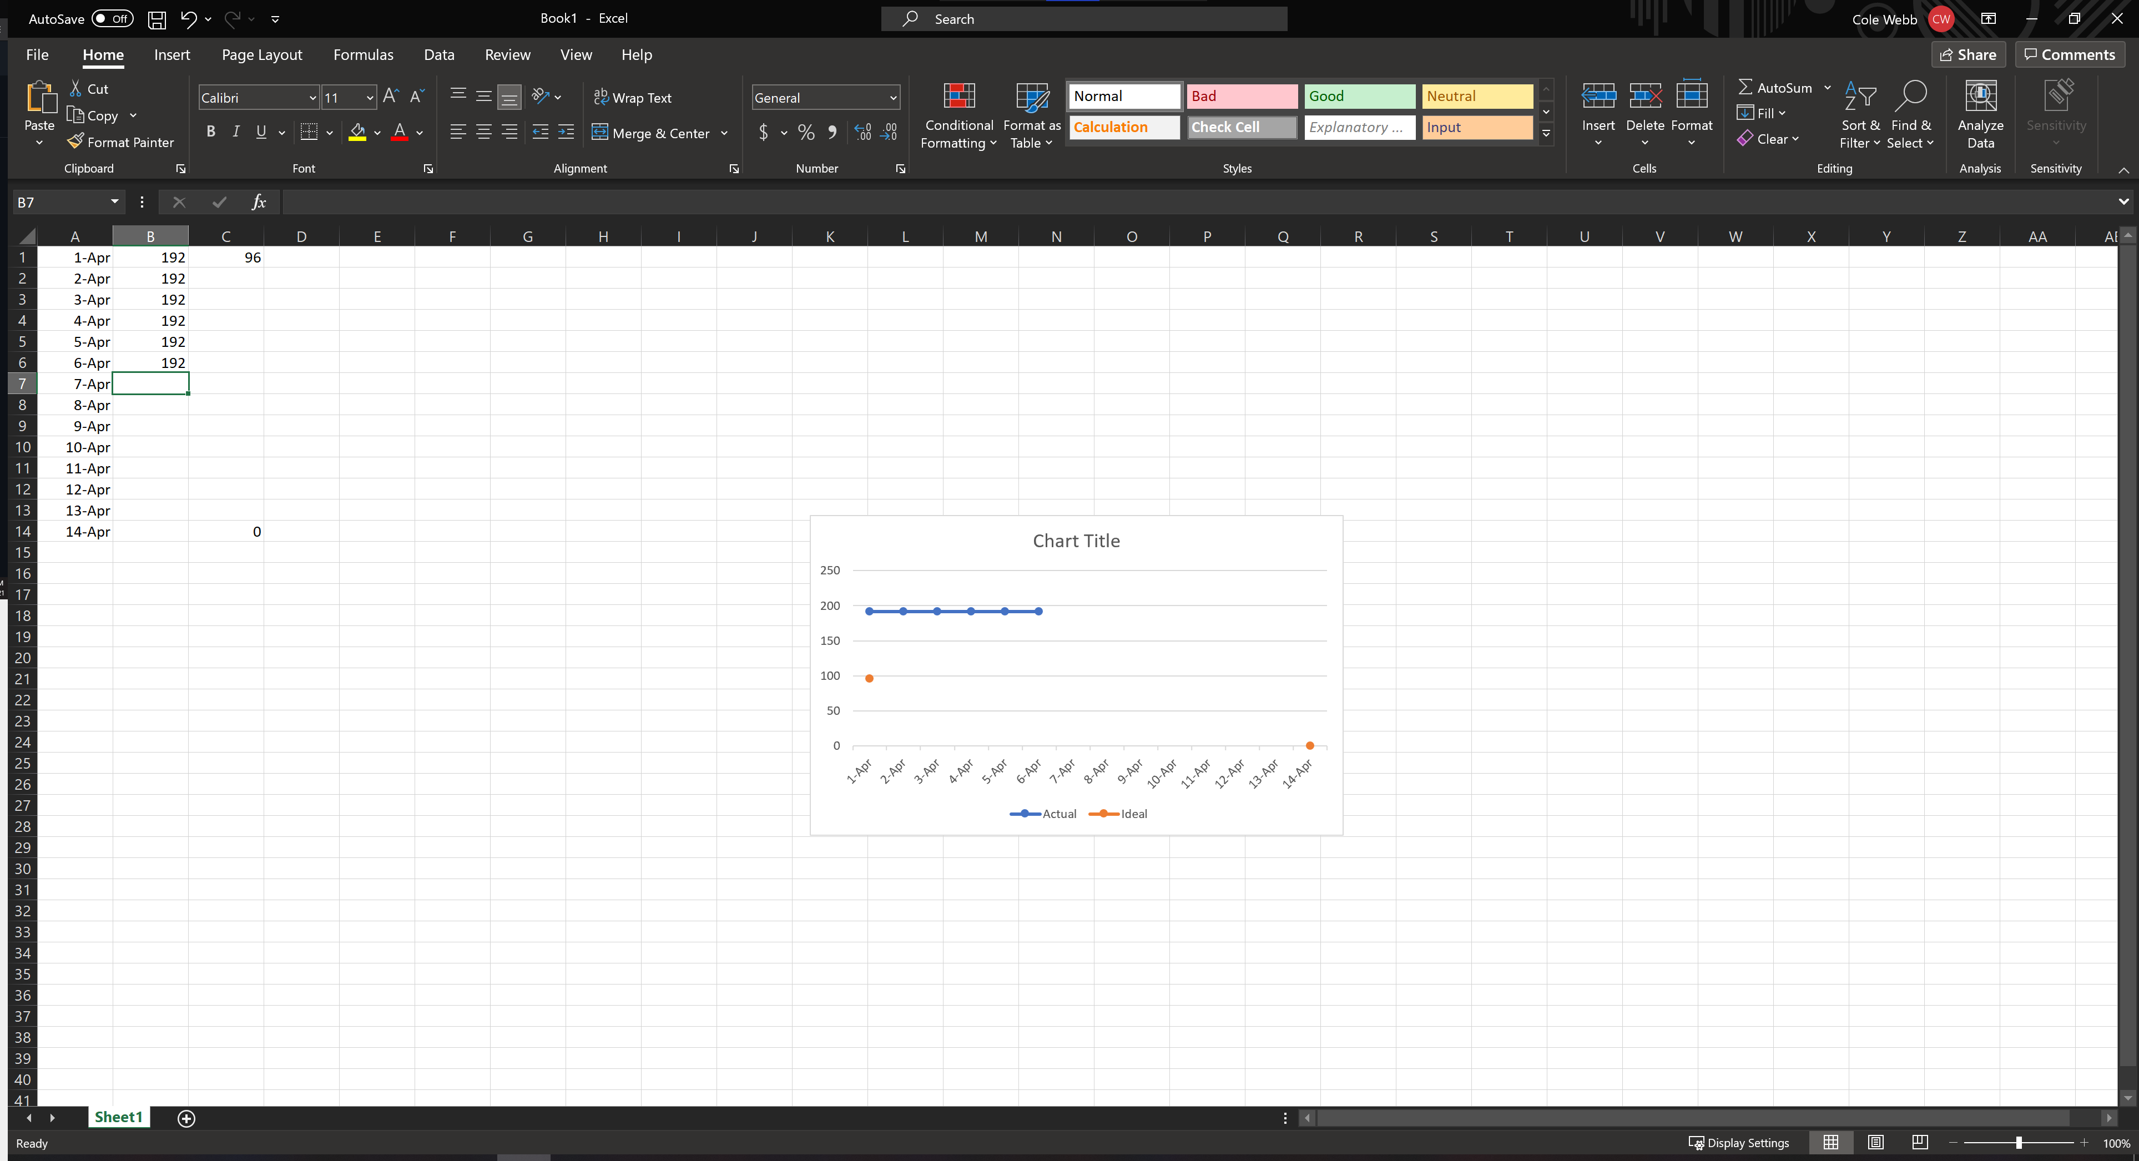

# Screenshot of you project board

